<https://atcoder.jp/contests/abc190/tasks/abc190_d>

Q.) How many arithmetic progressions consisting of integers with a common difference of 1 have a sum of n?

Approach:-

Series :- a,a+1,a+2,....,a+(x-1) [a-> first term, x-> length]

Sum= x*(2*a+(x-1))/2=n

x*(2*a+x-1)=2*n

x*(2*a+x-1)=m

Solution:-

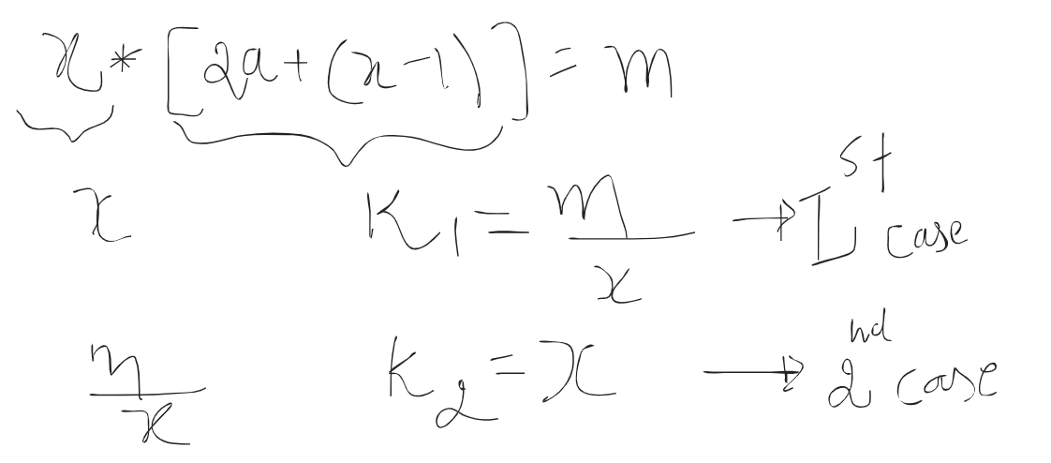

#define ll long long int

ll n;

cin>>n;

ll m=2*n, ans=0;

for(ll x=1;x*x<=m;x++){

if(m%x==0){

ll k1=(m/x),k2=x;

if((k1+1-x)%2==0) ans++;

if(k2!=k1 && (k2+1-(m/x))%2==0) ans++;

//If true then you got a series whose first term(a) and length=x

}

}

cout<<ans<<endl;

Q:

Universe is defined by 2 elements -> s and t.

N universe are given .

Degree of connectivity is defined as

D(Ui,Uj) = Si+Sj+|ti-tj| , if |tui-tuj|<=m

0 Else

3 3 -> n and m

0 0 -> 1st universe

3 0 -> 2nd universe

9 2 -> 3rd universe

D(1,2) = 3

2<=n<=10^5

0<=m<=10^16

0<=si,ti<=10^16

Si+Sj+|ti-tj| -> Si+Sj+ti-tj . if ti>tj

Si+Sj+tj-ti, if tj>ti

Si+Sj+ti-tj = (si+ti) + (sj-tj)

Deque -> possible universes for that i that satisfy ti-t<=m

F…….b

B -> push i s-t =9

4,5,6

<https://codeforces.com/problemset/problem/582/A>

| int main() {  int n;  cin>>n;  map<int,int,greater<int> > freq;  // store frequency of all elements  for(int i=0 ; i<n*n; i++)  {  int num;  cin>>num;  freq[num]++;  } vector<int> ans; for(auto it=freq.begin(); it!=freq.end(); ) {  if(it->second>0)  {  freq[(it->first)]--;  for(int i=0; i<ans.size(); i++)  {  freq[__gcd(ans[i],(it->first))]-=2;  }  ans.push_back(it->first);   }  else  {  it++;  } } for(int i=0; i<n; i++)  {  cout<<ans[i]<<" ";  } } |
| --- |
|  |

Time complexity: O(n2 log(n))